SQL Murder Mystery

- The first step was studying, analyzing and exploring the database to understand the information and to do that, I made and exhaustive analysis of the schema diagram of the tables.

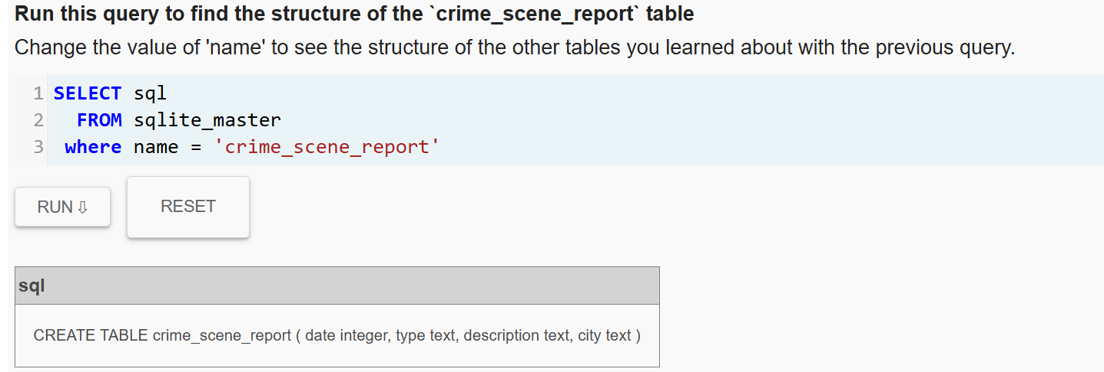

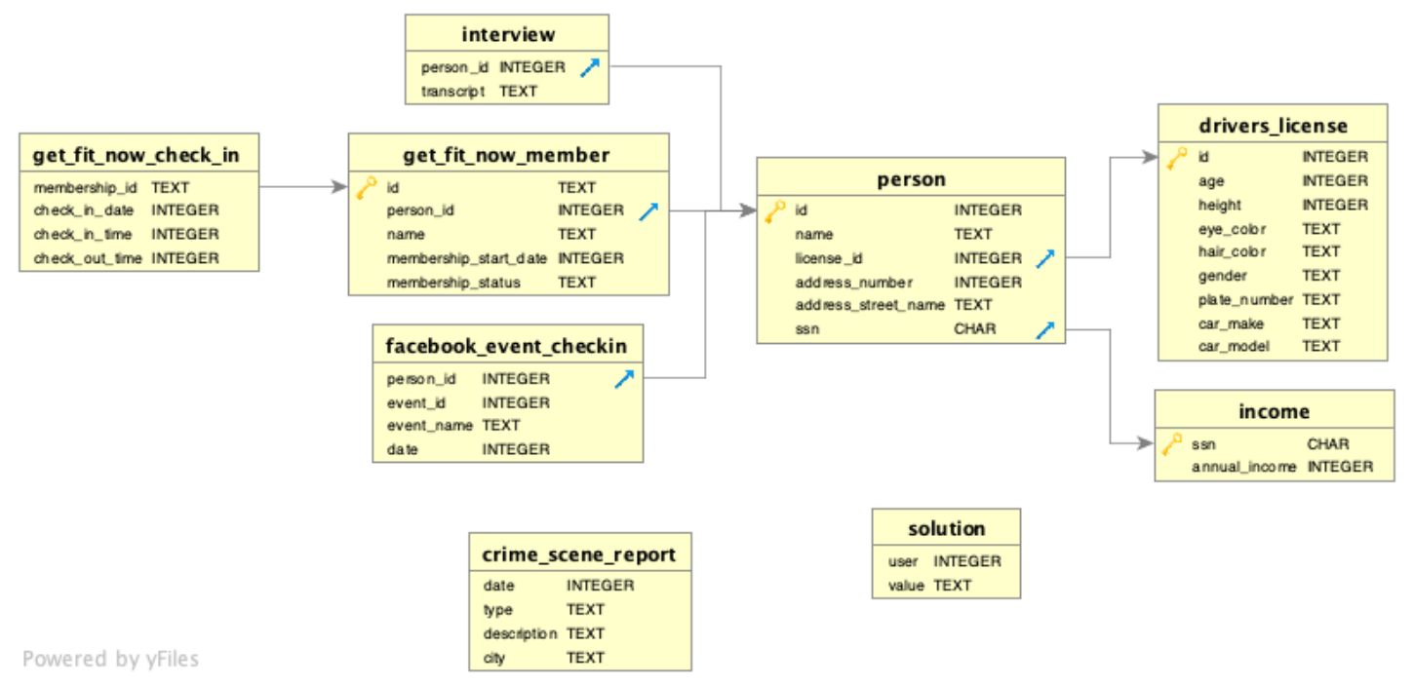

- the table who catch my attention was interview because it has all people’s declarations and
I made a compose query interacting with two tables : Interview and person to get the names of the persons and their declarations in the interview seeking some clue with the killer: some crime witness, or suspicius.person or somebody with information about the murder.
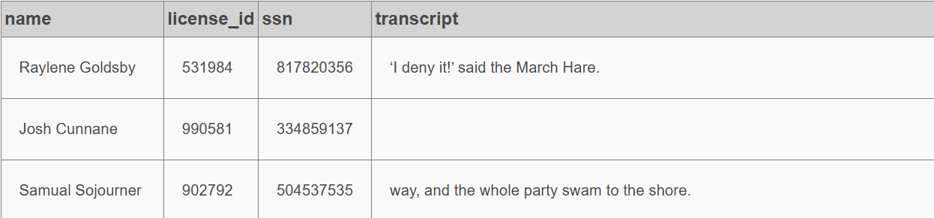
- After this query, I have a table with the name of the persons and the declarations they made. But I need to analyze the declarations where people talk about the murder or crime. To do that, I will do another query analyzing the key words like “killer”, “murder” in all declarations to get more important information.
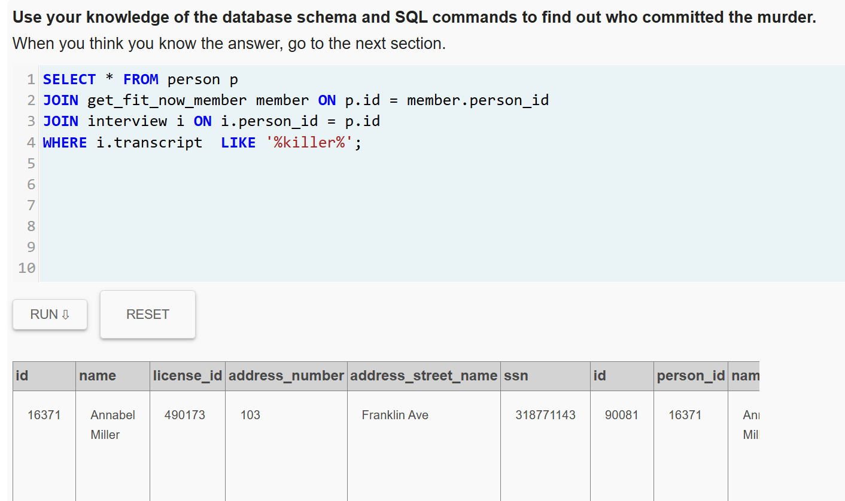
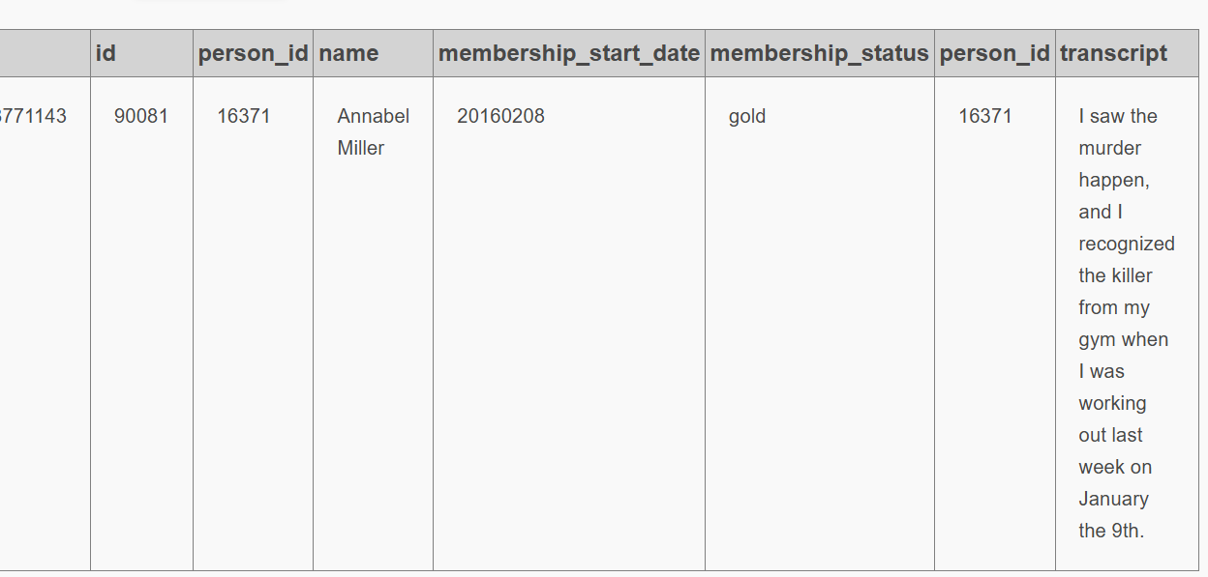

- Now I have a name Anabel Miller, it is the only person who in her declaration talk about the killer, she saw him in the gym. Then I have another tables with the people member of this gym.
I will do another query to get the persons who are member of this gym

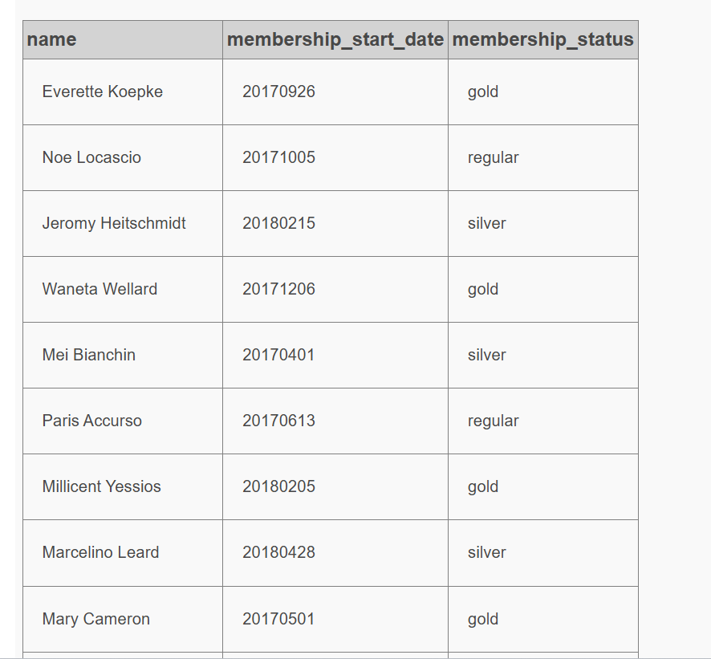
4) Annabel Miller said in her declaration he saw the murder for last time on January 9th in the gym. In next query I will check all members who did check in this month and day
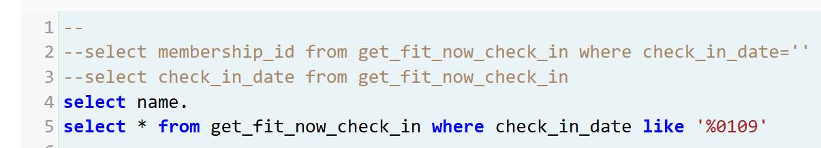

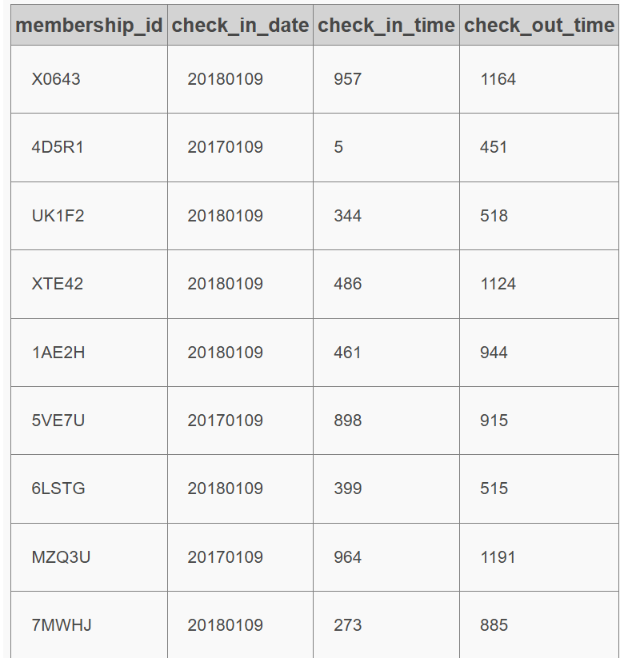

5) I am checking what specific year of January 9 Annabel went to the gym
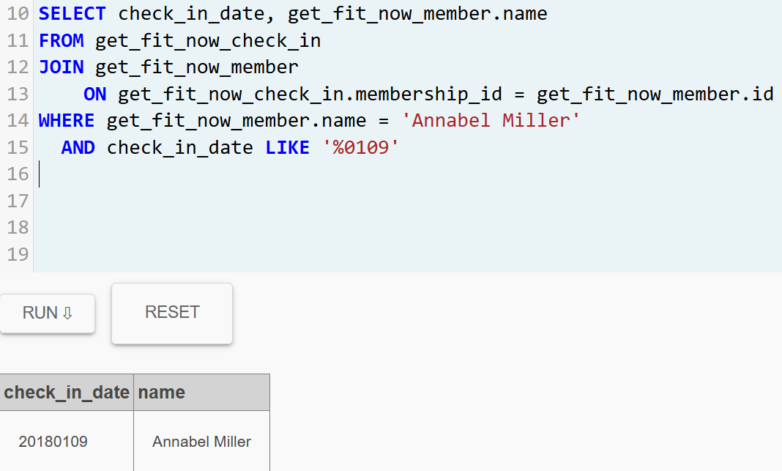

6) With this information I got the year and now I have the complete date where Annabel was with the murder in the gym. I can check all member who did the check_in on this date and one of them is the murder.
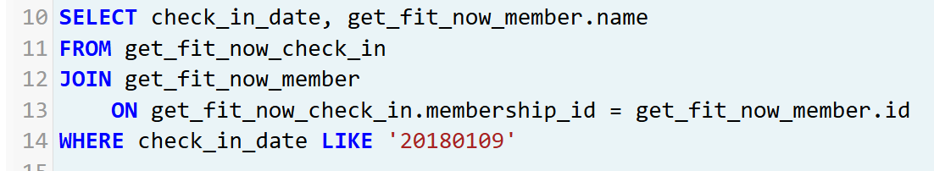
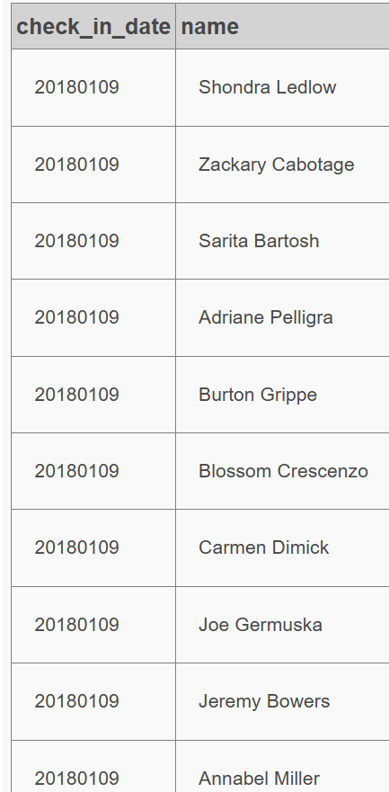
7) Because Annabel declaration i understand the murder is a man and the only men in the list are:

-Joe Germuska
-Jeremy Bowers
-Burton Grippe

Doing other investigations with these names my conclusion is Jeremy Bowers was the killer
